**Computer Programming 1  
Essential Standard 3.00 Apply Procedures to Construct Windows Forms**

1. Create a new project called Games
   1. Add the following controls

|  |  |  |
| --- | --- | --- |
| **Control** | **Name Property** | **Text Property** |
| Form | *You may leave it Form1* | Video Games |
| Button | btn*Game1* | *Add the name of a video game.* |
| Button | btn*Game2* | *Add the name of a video game.* |
| Button | btn*Game3* | *Add the name of a video game.* |
| Button | btn*Game4* | *Add the name of a video game.* |
| Label | lblGameInfo | *Empty* |

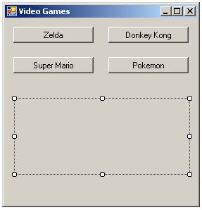

1. For each Button control, create a Click event.
2. btn*Game1* Click Event
   * 1. Add the text to your lblGameInfo
        + Example: lblGameInfo.Text = “The Legend of Zelda is a fantasy action-adventure game.”
   1. btn*Game2* Click Event
      1. Add the text to your lblGameInfo
   2. btn*Game3* Click Event
      1. Add the text to your lblGameInfo
   3. btn*Game4*Click Event
      1. Add the text to your lblGameInfo
3. Create a new project called Pizza
   1. Add the following controls

|  |  |  |
| --- | --- | --- |
| **Control** | **Name Property** | **Text Property** |
| Form | *You may leave it Form1* | Your Pizza |
| Label | lblChoice1 | *Empty* |
| Label | lblChoice2 | *Empty* |
| Label | lblChoice3 | *Empty* |
| GroupBox | grpChoices | Your Choices |
| CheckBox | chkPepperoni | Pepperoni |
| CheckBox | chkCheese | Cheese |
| CheckBox | chkMushrooms | Mushrooms |

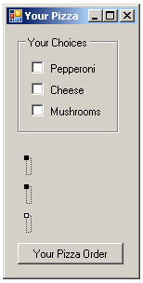

* 1. For each CheckBox control, create a Click event.
  2. chkPepperoni Click Event
     1. Add the following text to your lblChoice1: “You chose to add pepperoni.”
  3. chkCheese Click Event
     1. Add the following text to your lblChoice2: “You chose to add cheese.”
  4. chkMushrooms Click Event
     1. Add the following text to your lblChoice3: “You chose to add mushrooms.”
  5. Run and test your program.

1. Create a new project called Cookies
   1. Add the following controls

|  |  |  |
| --- | --- | --- |
| **Control** | **Name Property** | **Text Property** |
| Form | *You may leave it Form1* | Cookie Shop |
| Button | btnOrder | Order |
| Label | lblChoice | *Empty* |
| GroupBox | grpChoices | Your Choices |
| RadioButton | radChocChip | Chocolate Chip |
| RadioButton | radOatmeal | Oatmeal Raison |
| RadioButton | radPeanutButter | Peanut Butter |

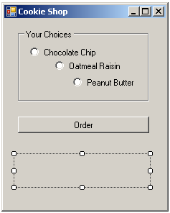

* 1. For each RadioButton control, create a Click event.
  2. radChocChip Click Event
     1. Add the following text to your lblChoice: “You chose our chocolate chip cookies.”
  3. radOatmeal Click Event
     1. Add the following text to your lblChoice: “You chose our oatmeal raisin cookies.”
  4. radPeanutButter Click Event
     1. Add the following text to your lblChoice: “You chose our peanut butter cookies.”
  5. btnOrder Click Event
     1. Add the following text to your lblChoice: “Order MORE Cookies.”
  6. Run and test your program.

1. Create a Project called Sandwich
   1. Add the following controls

|  |  |  |
| --- | --- | --- |
| **Control** | **Name Property** | **Text Property** |
| Form | *You may leave it Form1* | Sandwich Shop |
| Label | lblMainChoice | *Empty* |
| Label | lblChoice1 | *Empty* |
| Label | lblChoice2 | *Empty* |
| Label | lblChoice3 | *Empty* |
| GroupBox | grpMain | Main Choice |
| RadioButton | radHam | Ham |
| RadioButton | radTurkey | Turkey |
| GroupBox | grpChoices | Condiments |
| CheckBox | chkMayo | Mayonnaise |
| CheckBox | chkMustard | Mustard |
| CheckBox | chkCheese | Cheese |

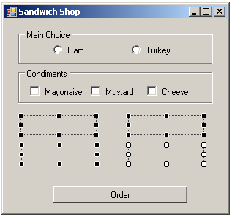

* 1. For each control, create a Click event.
  2. radHam Click Event
     1. Add the following text to your lblMainChoice: “You chose the ham sandwich.”
  3. radHam Click Event
     1. Add the following text to your lblMainChoice: “You chose the turkey sandwich.”
  4. chkMayo Click Event
     1. Add the following text to your lblChoice1: “You would like mayonnaise.”
  5. chkMustard Click Event
     1. Add the following text to your lblChoice2: “You would like mustard.”
  6. chkCheese Click Event
     1. Add the following text to your lblChoice2: “You would like cheese.”
  7. Run and test your program.

1. Create a project called Bikes.  
     
   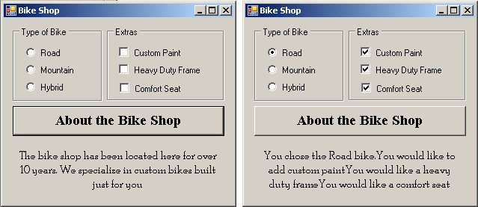
   1. Add the controls seen in the example above.
      1. Make certain you name them properly.
   2. Add the button click event that will display the text for “About the Bike Shop”
   3. Add the CheckChanged event for the RadioButtons and the CheckBoxes.
      1. Display appropriate text in the label.
      2. Make certain you have your text add to the existing text in the label.